***SDLC MODELS***

* ***WATERFALL MODEL***

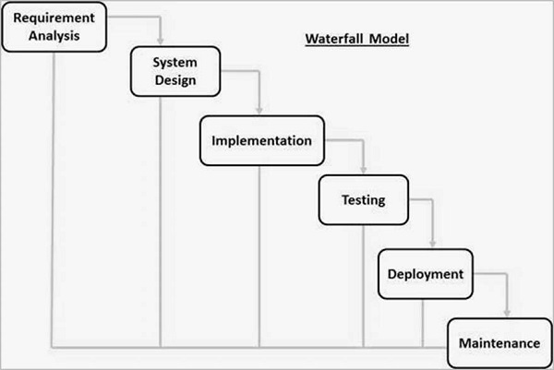

* ***V MODEL***

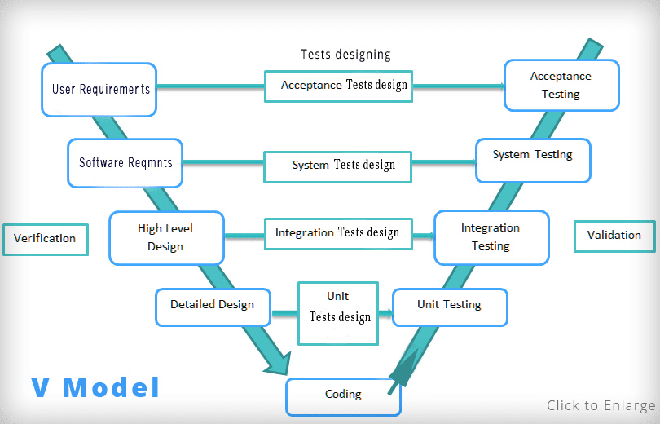

* ***AGILE MODEL***

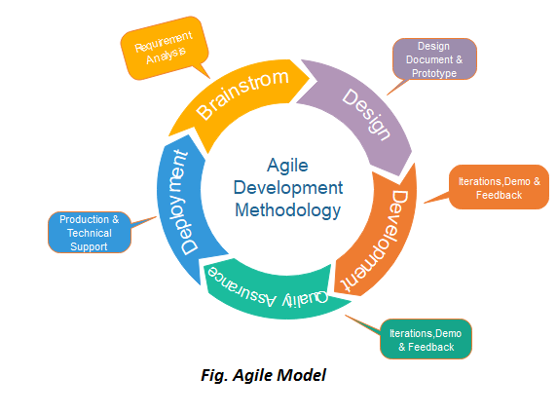

* ***ITERATIVE MODEL***

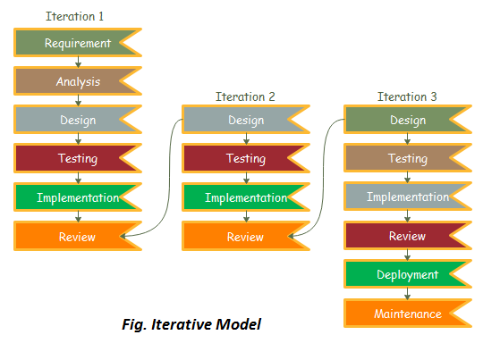

* ***EXAMPLE OF E-COMMERCE WEBSITE***
* **Planning:** In the planning phase, the eCommerce project manager and business analyst will collect requirements from stakeholders regarding how the eCommerce platform will work and what features it requires. Then, they will create detailed SRS (Software Requirement Specification) documents. After this, the business analysts will get the SRS documents reviewed by the key policymakers and stakeholders to get them approved.
* **Designing:** The SRS documents will be sent to the eCommerce software development team at this stage. First, the development team will carefully review the document to understand client requirements. Then, eCommerce developers will build a suitable architecture, and designers will create web pages after approval.
* **Development:** Coders will take over eCommerce platform development in this phase. They will code the web pages and APIs required to add various functionalities.
* **Testing:** In this step, the tester will do end-to-end functionality testing. They will ensure that the e-commerce platform is working seamlessly without any bugs.
* **Deployment:** At last, the developers will deploy code and offer end-users the final version of the e-commerce solution. After that, a similar process will be followed while integrating the latest features.